Annie Rubel
3495 Burns Ave
Detroit, MI 48214
Indian Village Historic District

Proposed Patio Materials Information

Pavers: Unilock Beacon Hill Flagstone in Fossil

https://unilock.com/product/beacon-hill-flagstone-michigan/

Soldier Course: Unilock Copthorne Brick in Old Oak

https://unilock.com/product/copthorne-michigan/

Seating Wall: Rivercrest in Buff with corresponding coping stone

https://unilock.com/product/rivercrest-wall-michigan/

Pavers:
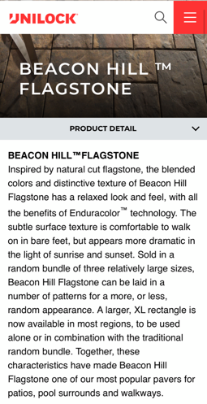

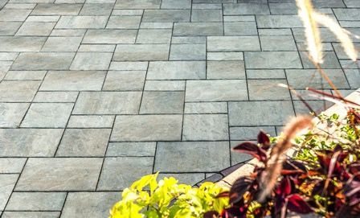

(Color: Fossil)
Soldier Course:

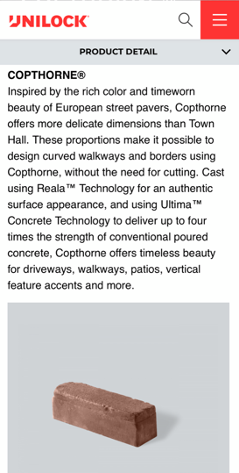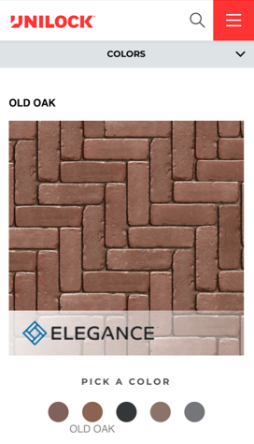

2.5’ Seating Wall:

