March 25, 2024

City of Detroit Historic District Commission
Attn: Jennifer Ross and Dan Rieden
2 Woodward, Suite 808
Detroit, MI 48226

RE: Scripps District Development Alley Construction

Jennifer/Dan,

The purpose of this memo is to provide additional information relating to the HDC submittal we recently made on behalf of Annette Covington, who lives at 3669 Lincoln Street. The request is in regard to removing the remnants of a crumbling wall at the back of her property. As stated in our application, the wall is in extreme disrepair and must be removed in order to construct the new alley pavement as part of our Scripps District development. We have provided pictures of the current condition, but visiting the site in person makes it obvious that the wall remnants must be removed for safety purposes alone. Our contractor informed us that the remnants of this wall are affecting the grade at which the alley needs to be built, and is leaning over in a dangerous way.

Ms. Covington has provided a letter stating that our team (3701 Lincoln LLC) has permission to remove the wall and any portions thereof for safety reasons, and to install a fence in its place that will match the recent fence installed by neighboring property to the south, for continuity purposes. This is a black aluminum fence, which can be seen during a site visit and in pictures below. Our plan will be to add dirt as needed, fine grade and seed the area after removal of the wall remnants prior to installing the new fence.

We appreciate the review of this application and look forward to continuing the Scripps District development, which includes significant historic elements such as the rehabilitation of the former Scripps mansion powerhouse building, and the salvaging and refurbishing of the existing stone columns on the property. Our plan has us opening for sales in May, which requires quick resolution to the removal of the dilapidated brick wall.

Proposed Fence Install (to match existing adjacent neighbor to the south)

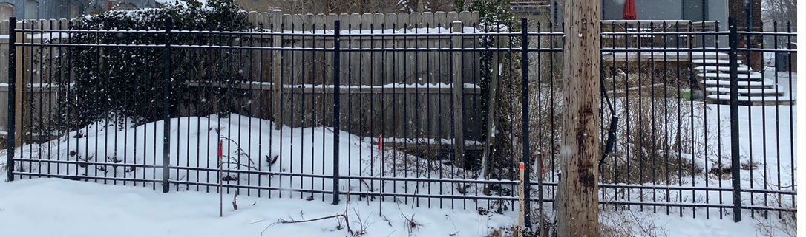

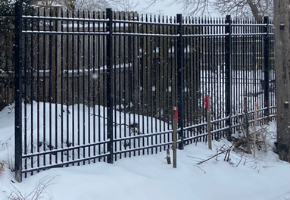

Respectfully,

Tim Loughrin | VP of Land Acquisition
Robertson Brothers Homes
6905 Telegraph Rd, Suite 200, Bloomfield Hills, MI 48301
Direct Dial: 248.282.1428 | Mobile: 248.752.7402
tloughrin@robertsonhomes.com

