762 Seminole Current Conditions and Scope of Work
Current Conditions:
762 Seminole is finished in a combination of Stucco and exposed brick. Overall the stucco is in reasonable condition. Stucco on both chimneys and front porch is however in need of immediate repair. Large sections of stucco have begun to separate from the common brick and present a safety hazard. The roof of the front porch is beyond repair and is allowing water to leak underneath. This has resulted in the second floor brick columns separating from their footing. Water intrusion is causing the stucco to deteriorate rapidly and is impacting the integrity of the historically significant arches.
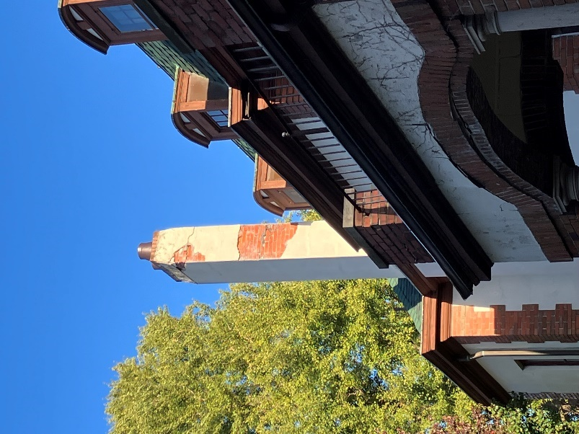a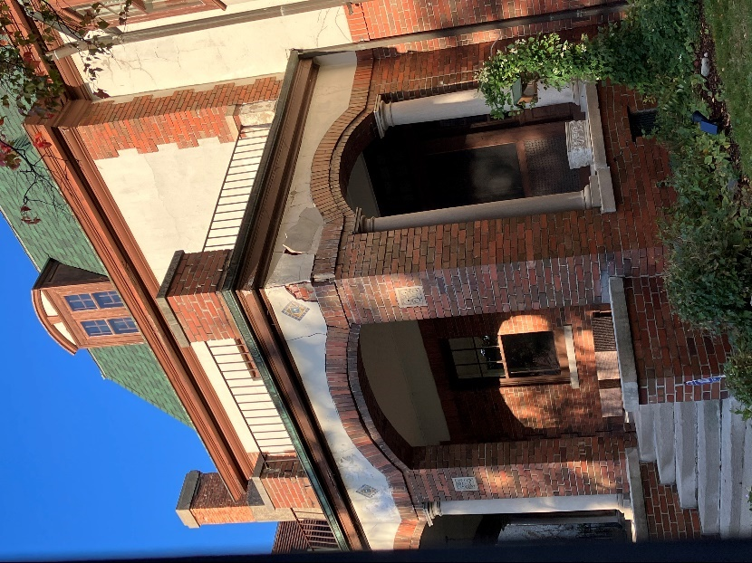
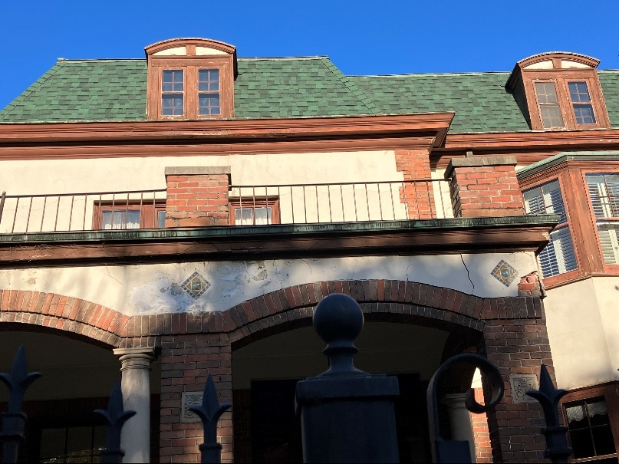

Scope of Work
- Chimneys
  - Remove stucco to a solid termination point retaining decorative tile
  - Replace and repoint common brick as required to restore structral rigidity
  - Reinstall original flus and new caps
  - New stucco / parging to be done down to roof line matching existing finish
  - Reinstall original decorative tile
  - Stucco to be painted in a breathable masonry paint to match extant “cream” color
  - Lime mortar and existing brick to be used for repairs. If needed, reclaimed brcik to match original dimensions and color will be used
- Front Porch
  - 2nd Floor
    - Remove existing front porch flat roof
    - Rebuild second floor maonry columns
    - Repoint and repair brick under the flat roof
    - Install a new rubber membrane roof
    - Reinstall and paint extant decorative iron guard railings
  - 1st Floor
    - Remove stucco and retain decorative tile
    - Repair decorative masonry arches by re-setting extant brick and utilizing a color matched mortar
    - Repoint common brick under stucco utilizing a lime mortar
    - New stucco to be installed matching existing finish
    - Stucco to be painted in a breathable masonry paint to match extant “cream” color
- General Masonry Repairs
  - Stucco to be repaired as and where needed on the body of the house / garage and painted to match extant color scheme
  - Exposed brick to be tuckpointed and reset as and where needed on the body of the house / garage.

10.30.23 Minor Revision
- Front Porch
  - 2nd Floor
    - Rather than installing the previously noted new rubber membrane (flat) roof, a pitched (2 ½”) standing seam metal roof would be installed. Note that pitch (2 ½”) will not obstruct the front 2nd floor window.

