 | DEGC Project Evaluation Checklist
3740 Second Mixed-Use New Construction
Developer: Greatwater Capital
Principles: Jed Howbert & Matt Temkin
 | Neighborhood Enterprise Zone, PA 147 New – New allocation; exemption for the development of residential housing located within eligible distressed communities. Full taxable value taxed at discounted rate determined by the until the final three years when phase out occurs.
 | DEGC Recommendation | Approval of the NEZ District
 | Request Type | NEZ District
 | Location
 | Address | 3740 Second
 | City Council District | District 5
 | Neighborhood | Midtown
 | Building Use
 | Residential Square Footage | 25,410
 | Retail Square Footage | 3,000
 | Parking Spaces | 44; SD2 Zoning does not require retail parking
 | Project Description
 | 3740 Second Avenue is a 4-story mixed-use new construction development at the corner of 2nd Ave and Brainard St. This new construction development will create 57 residential studio and one-bedroom units and 3,000 SqFt of commercial space to be used for added amenities for the residents and surrounding community. 20% of the residential units are income restricted for residents making 80% AMI or below and the remaining units are below 120% AMI to create workforce housing. The developer has recently completed construction and is leasing two nearby buildings at: 3444 Second Ave and 686 Brainard. The adjacent property at 8484 Brainard is being renovated and will be complete by June 2022.
 | Rental Breakdown
 | Total Units | 57 Residential Units
 | Affordable Units | 7 Studio units; 5 one-bdrm units = 12 units at 80% AMI
 | Studio | 26 units, 370sf; $1,150/mo rent
 | 1 Bedroom | 19 units, 550sf; $1,400/mo rent
 | Underwriting
 |  | With Incentive | Without Incentive
 | Internal Rate of Return | 13.1% | 8.1%
 | Cash on Cash | 11.4% | 7.1%
 | Project Costs
 | Total Investment | $11.8M
 | Uses | $9.3M Hard Construction (79%), $2.5M Soft Costs (21%)
 | Sources | $5.9M Equity (50%); $5.9 million (50%)
 | Project Benefits (15 years)
 | Estimated jobs | 0 FTE, 30 construction jobs
 | Estimated city benefits before tax abatement | $1,722,614
 | Total nominal value of NEZ | $467,834
 | Less cost of services & utility deductions | $411,013
 | Net benefit to city | $843,767

Location
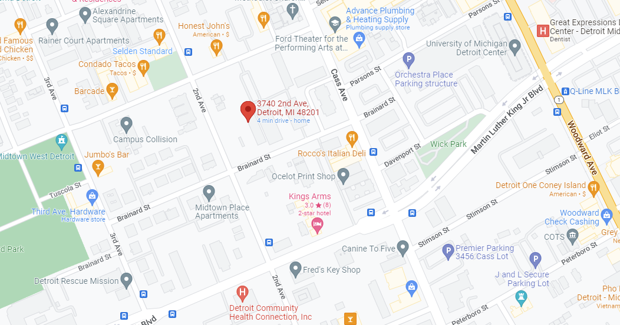
Street View
